**User Manual for Travelling Salesman Problem - Genetic Algorithm**

Zachary Petrusch, Nicklaus Benedict, Eric McAlpine, and Alex Lee

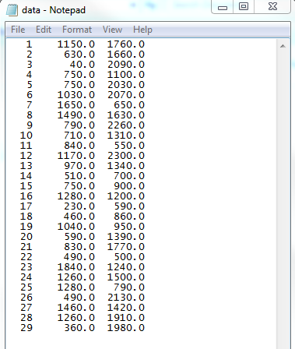The code is set up to run in Visual Studio with debug mode on. Running the code requires a text file with TSPLIB formatted data. The text file should only contain the city data from the TSPLIB file; the header and EOF should be removed. The picture below shows an example of the correct format.

Figure 1 The Correct Format for City Data File

There is also a global variable named NUM_CITIES that must be set equal to the number of cities in that data set. The file that should be read also needs to be placed into the file reader “.open” command in Source.cpp. Provided with the code base are a few sample data files; 29 cities and 51 cities. The name of the file states how many cities along with the length of the optimal solution. For example, in the below open command the optimal path would be 27,603.

C:\Users\zgp1001\Pictures\Capture2.PNG

Figure 2 File Open Statement

The parallel solution can be turned on or off by using the Visual Studio master-switch for parallel OMP. This setting can be found under Project Properties -> C/C++ -> Language -> Open MP Support -> Yes. Another option for turning some parallel on or off is the global variable NUM_THREADS can be set to 1. It should be noted that this will only turn of certain sections of parallel code in our code, and that some aspects will still run in parallel. Therefore turning the master-switch inside Visual Studio is the best way to turn parallel on or off.